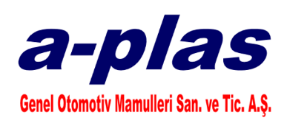

***OCCUPATIONAL HEALTH AND SAFETY POLICY***

*We, A-PLAS GENEL OTOMOTİV MAMULLERI San. And Tic. A.S Family,*

*In our production of plastic components for the automotive industry, we aim to create, maintain and continuously improve a healthier and safer working environment for our employees, guests and subcontractors as a business with Occupational Health and Safety awareness.*

*In line with this purpose,*

*- Fulfil all legal and other obligations,*

*- To assess hazards to minimise the effects of risks arising from machinery and work equipment in the workplace,*

*- Taking protective measures,*

*- To raise awareness by providing OHS trainings to our employees,*

*- To be prepared for emergencies that may occur by taking the necessary precautions,*

*- To ensure the safe use of chemicals in the workplace,*

*- To prevent possible risks with the aim of fire protection and to raise awareness by training employees,*

*- To implement Incident and Accident Management in order to reduce work accidents,*

*- To raise awareness of employees about Workplace Ergonomics and to make improvements in this regard,*

*- Personal Protective Equipment given to employees according to the hazard and risk of the work performed*

*To ensure and supervise the use of equipment,*

*is one of our main goals.*

*CHAIRMAN OF THE BOARD*

*Ahmet AĞAOĞLU*